**Name: _________________________ Date: ________________ Per.:______**

**Birds Part 2: Further _________________ modifications for _______________:**

* **Furcula** The ___________________ are ________________ to form a structure called the furcula or ______________________.
* 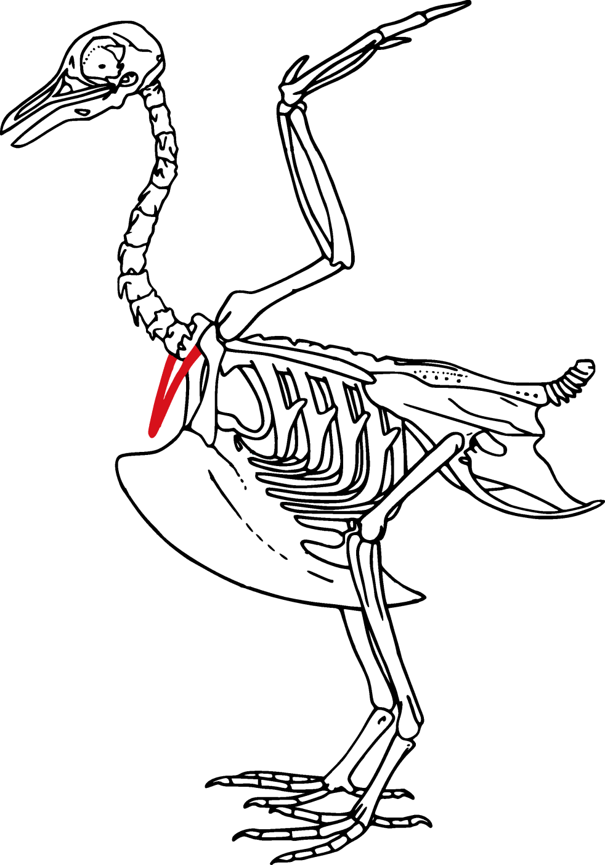The furcula _________________ during _________________ and spreads and _________________________ during each wing beat. The __________________ may enhance __________ _____________________ by assisting in moving ________ through the air __________.

___________________________ Principle - “When the ___________________ of a ____________________________ (air) ____________________, internal _________________________ in the fluid ______________________”

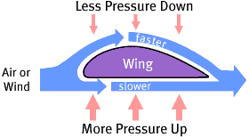

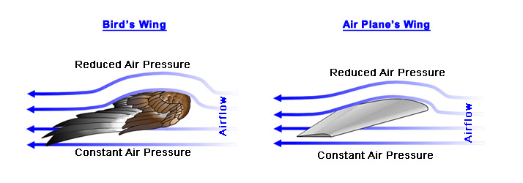______________ of birds wing = _______________ The high pressure ________________ the airfoil will be ____________________ than the low pressure ________________ the wing, causing the bird to “_____________” causing the bird to lift up.

Lift and thrust:

In order to fly both ___________________________ ______________________ and ________________________ _________________ are required.

Thrust is mainly generated by the __________________________ feathers (the _____________ ones at the end of the bird’s hand), which on the down _________________, twist and acting like a ______________________ push the air ___________________________. _______________ is mainly generated by the _______________________ feathers (the _______________ portion of the wing), which form an ____________________________.

Avian lungs:



* The _______________ - __________________flow of ______________ is achieved by using a system of air sacs and a __________ breath cycle.
* On ______________________, air ______________ down the _____________________ to air sacs below the ______________________. On _____________________ the air mass flows into the __________________ where __________ exchange takes place.
* With a second _________________________ the air mass in the ________________ flows into anterior ______________ _______________ and with a second ______________________ exits the body via the __________________________.

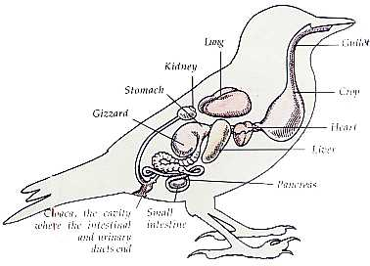Feeding and digestion:

* Because birds lack ____________________ they can’t process food much in the _________________ so that is left up to the __________________ system.
* Birds can frequently gather food __________________ than it can be _____________________. This food is usually ________________ in the bird’s ___________, an enlarged part of the ____________________________.
* The _____________ is also used to ________________ food that will later be ____________________________ to chicks.

Stomach:

* A bird’s stomach has ____________ ______________ the anterior __________________ proventriculus and the posterior ____________________________.

Gizzard:

* The gizzard’s main ______________________ is to mechanically ___________________ food.
* The _________________ of the gizzard are thick and _______________________ and the gizzard often contains small _________________, which the birds __________________ to assist in _______________________ the food. The gizzard thus fulfills the same ____________ as the ___________________ in mammals.

Sensory systems: vision:

Most birds have excellent vision and this is reflected in the structure of the brain.

* In contrast, in most birds olfaction is unimportant and the olfactory bulbs are small.

Hearing:

* Birds have hearing that is ______________________ in sensitivity to that of _________________ even though their _______________ are much ________________________.
* However, they have proportionally much larger ____________________ _______________________ which ________________ sensitivity to ________________. In addition, the __________________ has about ___________ as many hair __________ per unit in ________________ as a mammalian ____________________ does.

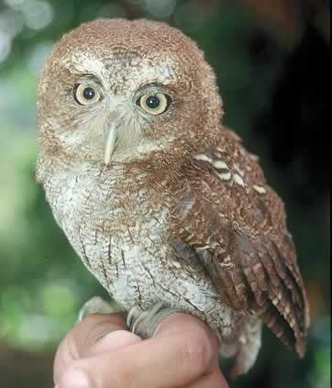 Owls possess the most _________________ hearing among birds

(comparable to that of a __________ ) and can

__________________ sounds very accurately even in complete

______________________.

Olfaction:

* [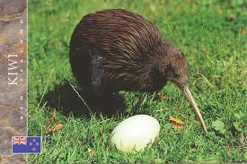](http://images.google.com/url?sa=i&rct=j&q=kiwi+bird&source=images&cd=&cad=rja&docid=eo0k9BUodKE-8M&tbnid=ImXxrIVy3iCJmM:&ved=0CAUQjRw&url=http://www.flickr.com/photos/veryhappyhomemaker/5120593477/&ei=iEMEUYfLFum40QG7zoBQ&bvm=bv.41524429,d.dmQ&psig=AFQjCNE-QHoCe8okl6ie1yyFbrpVlEQgpw&ust=1359320328738109)Most birds have a ________________________ developed sense of ________________________, but a few groups do have a good sense of smell.

Kiwis, the _____________________________ birds that are the

national symbol of New Zealand, appear to __________________

out their earthworm __________________.

[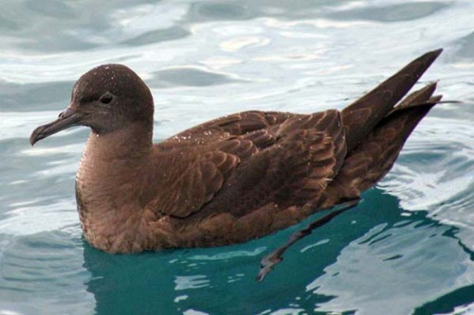](http://images.google.com/url?sa=i&rct=j&q=Sooty+Shearwaters+&source=images&cd=&cad=rja&docid=TM03Rj0ZPd16TM&tbnid=Q-JbSdmd6e8p2M:&ved=0CAUQjRw&url=http://www.ozanimals.com/Bird/Sooty-Shearwater/Puffinus/griseus.html&ei=bkYEUfyBOqnF0AGrr4GADQ&bvm=bv.41524429,d.dmQ&psig=AFQjCNGZyoJtMe1cQyUVtAgabfp9Z173Gg&ust=1359321071261343) Sooty Shearwaters and Northern Fulmars are attracted from

downwind to the __________________ of fish oils, squid, and krill.